ARCHIVES | 1975

Laser Is Utilized to Brand Fish in Water
By STACY V. JONES NOV. 1, 1975
Continue reading the main story Share This Page
- Share
- Tweet
- Email
- More
- Save
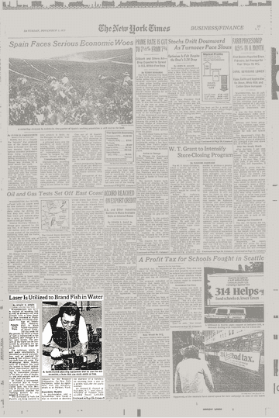

VIEW PAGE IN TIMESMACHINE
Patents of the Week
November 1, 1975, Page 35The New York Times Archives
By STACY V. JONESNOV. 1, 1975

WASHINGTON, Oct. 31 —A method of branding fish as well as domestic and wild animals with a laser beam has been invented at Washington State University's College of Veterinary Medicine. Prof. R. Keith Farrell was granted Patent 3,916,143 this week for the process by which a beam of light is transmitted to the creature's skin through a fiber optic bundle. The pattern of the brand can be controlled by arranging the optic bundle in the shape desired.
The technique, which is still under development, is described as quick and painless, and as practical for marking fish without removing them from the water. The Washington State Department of Fisheries has used the system to brand salmon. Other experimental applications have involved branding by irreversible changes in the hair or skin of domestic and wild animals such as cattle, dogs and deer.
Dr. Farrell, a veterinarian, is inventor also of freezebranding with cryogenically cooled tools. His wife, Bevf‐rly P. Farrell, has invented an unalterable alphabet for markihg animals by any branding technique.
The inventions of both the Farrells are being licensed to industry by the Research Corporation, the New York foundation, under its agreement with the university, which is at Pullman, Wash.
...
https://www.nytimes.com/1975/11/01/archives/laser-is-utilized-to-brand-fish-in-water-laser-branding-of-fish.html

ПЕРЕВОД ПУБЛИКАЦИИ

ARCHIVES | 1975

Laser Is Utilized to Brand Fish in Water
By STACY V. JONES NOV. 1, 1975
ПРИВЕДЕН В ТАБЛИЦЕ, РАСПОЛОЖЕННОЙ НИЖЕ :

Patents of the Week  November 1, 1975, Page 35The New York Times Archives  By STACY V. JONES NOV. 1, 1975  WASHINGTON, Oct. 31 —A method of branding fish as well as domestic and wild animals with a laser beam has been invented at Washington State University's College of Veterinary Medicine. Prof. R. Keith Farrell was granted Patent 3,916,143 this week for the process by which a beam of light is transmitted to the creature's skin through a fiber optic bundle. The pattern of the brand can be controlled by arranging the optic bundle in the shape desired.  The technique, which is still under development, is described as quick and painless, and as practical for marking fish without removing them from the water. The Washington State Department of Fisheries has used the system to brand salmon. Other experimental applications have involved branding by irreversible changes in the hair or skin of domestic and wild animals such as cattle, dogs and deer.  Dr. Farrell, a veterinarian, is inventor also of freezebranding with cryogenically cooled tools. His wife, Bevf‐rly P. Farrell, has invented an unalterable alphabet for markihg animals by any branding technique.  The inventions of both the Farrells are being licensed to industry by the Research Corporation, the New York foundation, under its agreement with the university, which is at Pullman, Wash.  https://www.nytimes.com/1975/11/01/archives/laser-is-utilized-to-brand-fish-in-water-laser-branding-of-fish.html | Патенты недели  Ноябрь 1, 1975, страница 35  Архивы Нью Йорк Таймс  Автор Стаси В. Джонс,ноябрь,1,1975  ВАШИНГТОН, Окт.31 - Метод клеймения рыбы , а также домашних и диких животных лазерным излучением был разработан в Колледже Ветери-нарной Медицины Вашингтонского Государственного Университета. Профессор Р.Кейт Фаррелл получил патент 3,916,143 на этой неделе на процесс , посредством которого излучение передается на кожу живого существа через волоконно - оптический пучок. Структура клейма может контро-лироваться путем организации оптического пучка в желаемой форме.  Технология, находящаяся в настоящее время в разработке, описана, как бы-страя и безболезненная, и применяется для клеймения рыбы без извлечения из воды. Вашингтонский государственный департамент рыболовства уже использу-ет систему для клеймения лосося. Дру-гие экспериментальные применения уже включают клеймение путем необрати-мых изменений в волосах или коже до-машних и диких животных, таких как крупный рогатый скот, собаки и олени.  Доктор Фаррелл, ветеринар, также изобрел клеймение холодом инструменамии , охлажденными криогенно . Его жена , Беверли П.Фаррелл, изобрела безбуквенный алфавит для клеймения животных посредством любой техники клеймения.  Открытия Фарреллов лицензированы для промышленности Корпорацией Исследований Фонда Нью-Йорка, по соглашению с университетом, который находится в г.Пулман, штат Вашингтон.

